**Note and maintenance**

1. Work environment

The best working environment temperature 25-30 degrees, humidity above 50%

2. The ink

Please try to use up the ink within 3 months after opening to avoid spoilage.

3. Shut down the device

After the work is completed, please turn off the equipment in the normal order, first turn off the printer button, then turn off the main power supply, keep the ink car on the far right, fit and seal with the waste ink pump, reduce the print head blockage.

1. Regularly clean up the waste ink cartridge and ink sponge

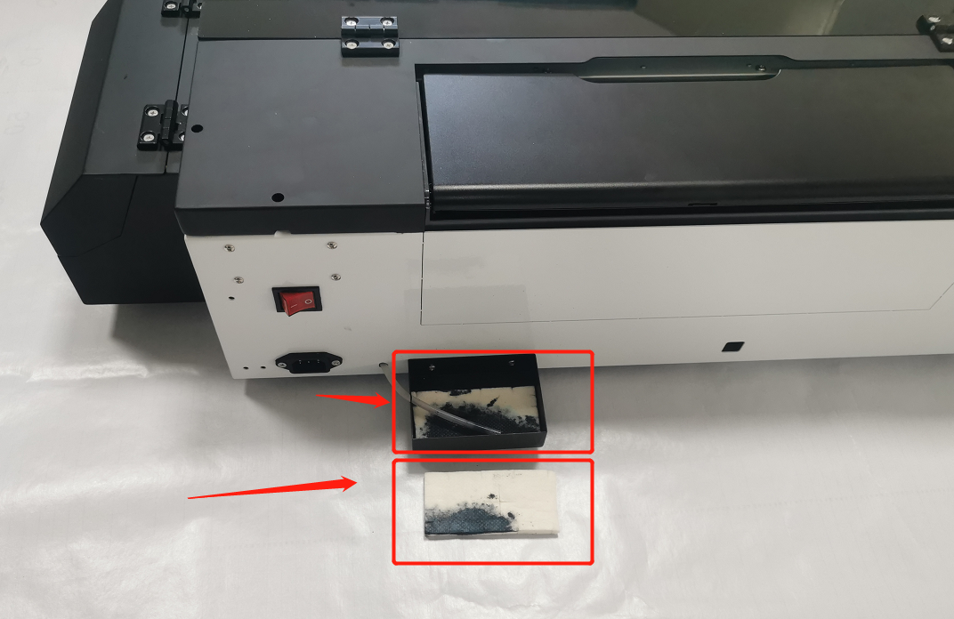

1. Clean and suck the ink on the left side of the machine regularly

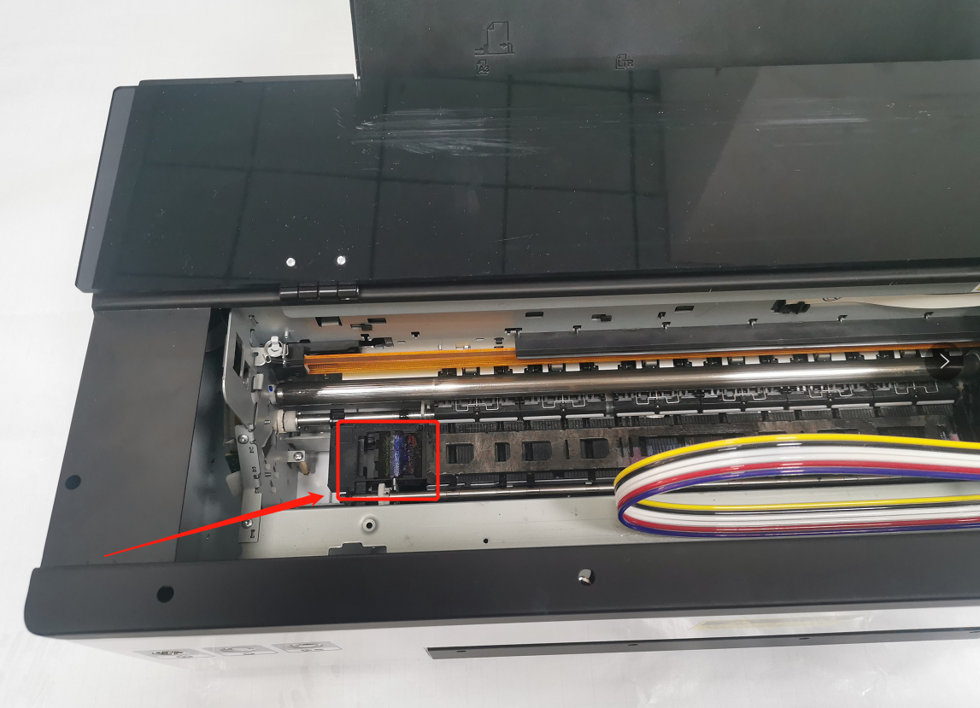

1. Clean the black lubricating oil on the ink car guide rail regularly, and add new lubricating oil to keep the ink car guide rail smooth.

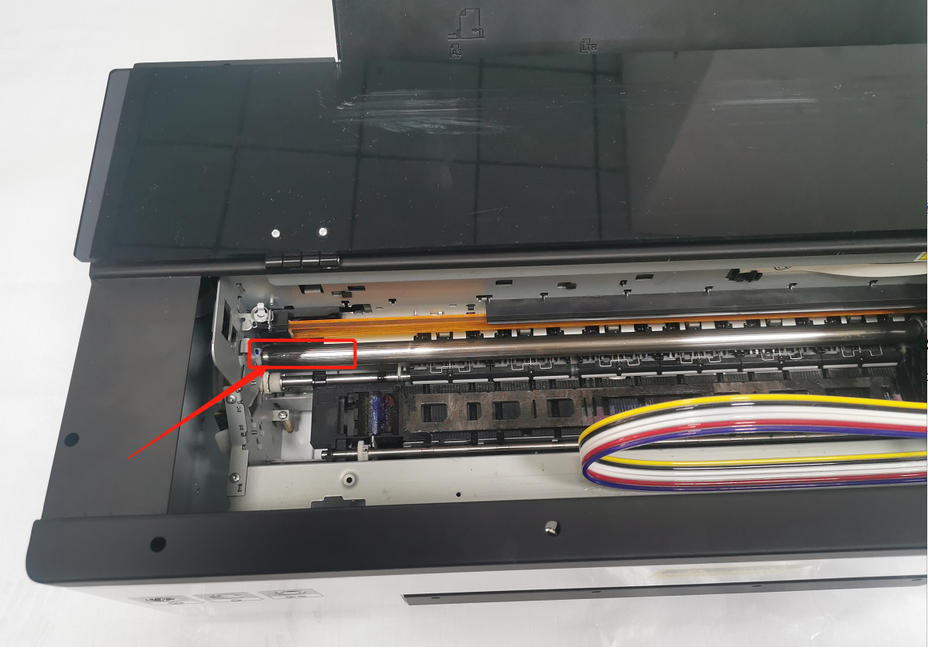

1. Clean the grating strips regularly with alcohol and dust-free cloth to ensure the printing accuracy.

